  
 **CSE231  
 SEC: 06  
  
 Project**   
 Seven-Segment Display  
 on  
 BABAFAFA  
 2nd Part  
 555 timer & sequential circuit

**Submitted to:** Dr Mohammad Monirujjaman Khan  
  
  
 **Group Members:**  
 1. Kazi Mahbub Jamil 1921626042  
 2. Mahinur Sazib Sristy 192105504

3. Md. Sihab Bhuiyan 1912403642  
 4. Md. Adib Sadman 1921050042  
  
  
 **Written By :**  
 Kazi Mahbub Jamil

**Date:** 14 Jan,2021  
 Table Of Content:  
 1. About 555 Timer

2. How 555 Timer Works   
3. Asynchronous & Synchronous circuit

4. Reason behind choosing Asynchronous circuit  
5. Table & Equation  
6. Sequential Circuit

7. Logisim  
  
  
  
  
  
  
  
  
  
  
  
  
  
  
  
  
  
  
  
  
  
  
  
  
  
  
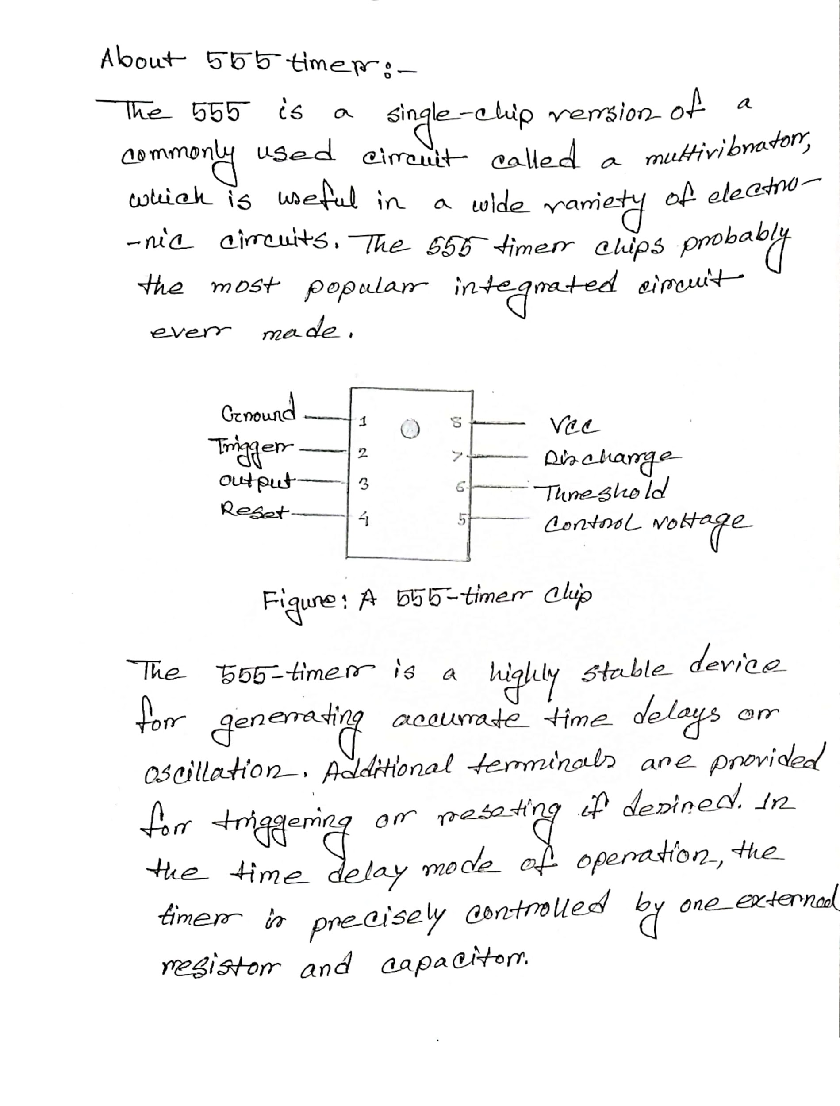  
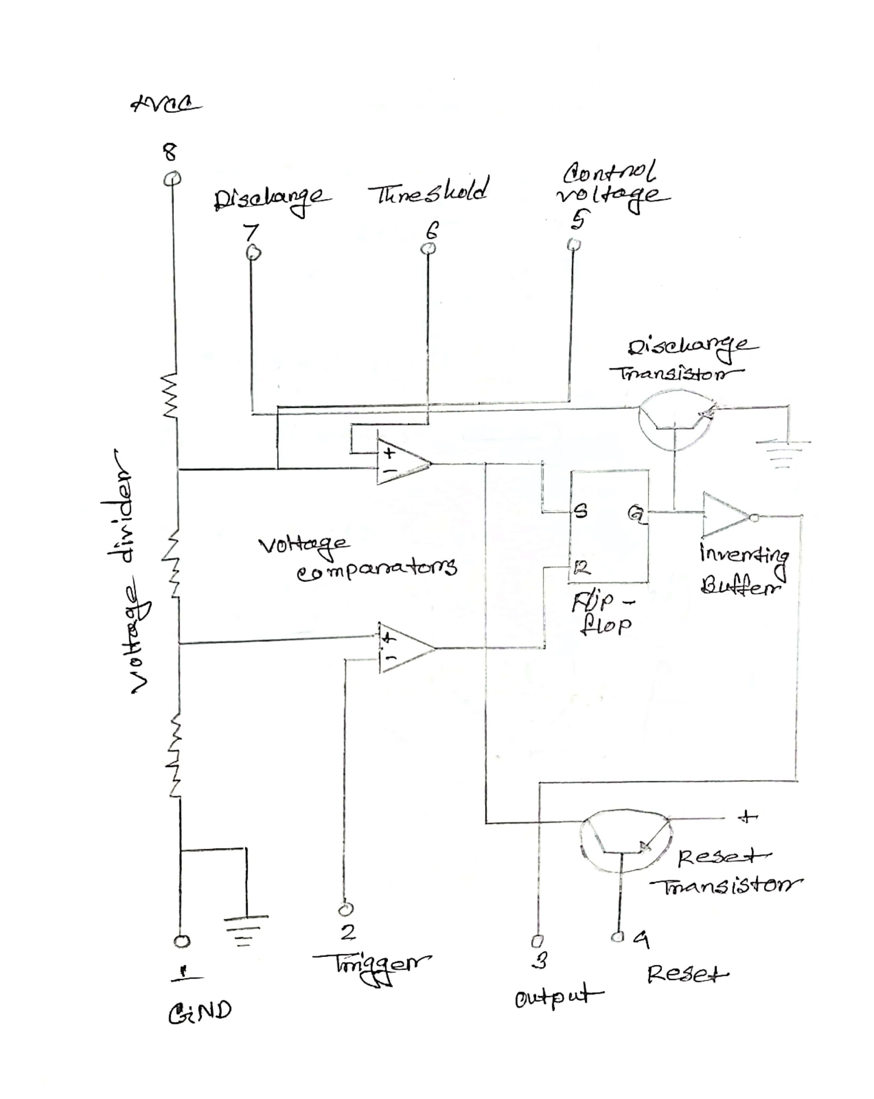  
  **Figure: Internal Construction Of 555 Timer  
  
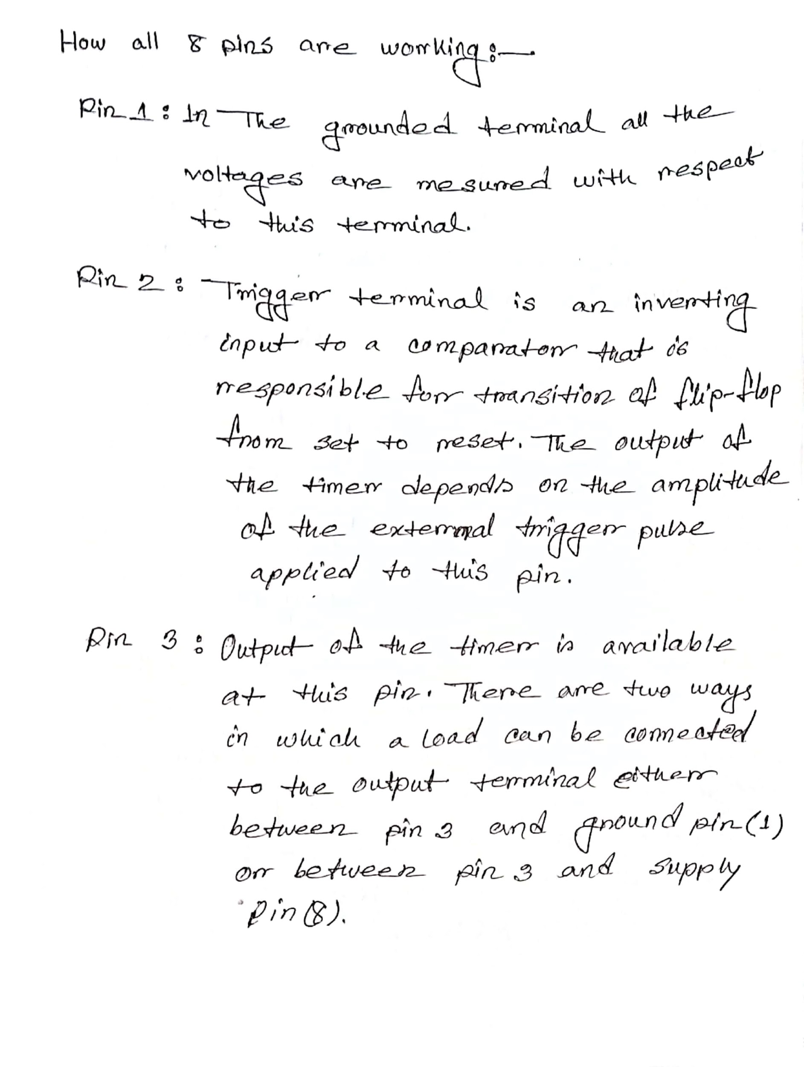  
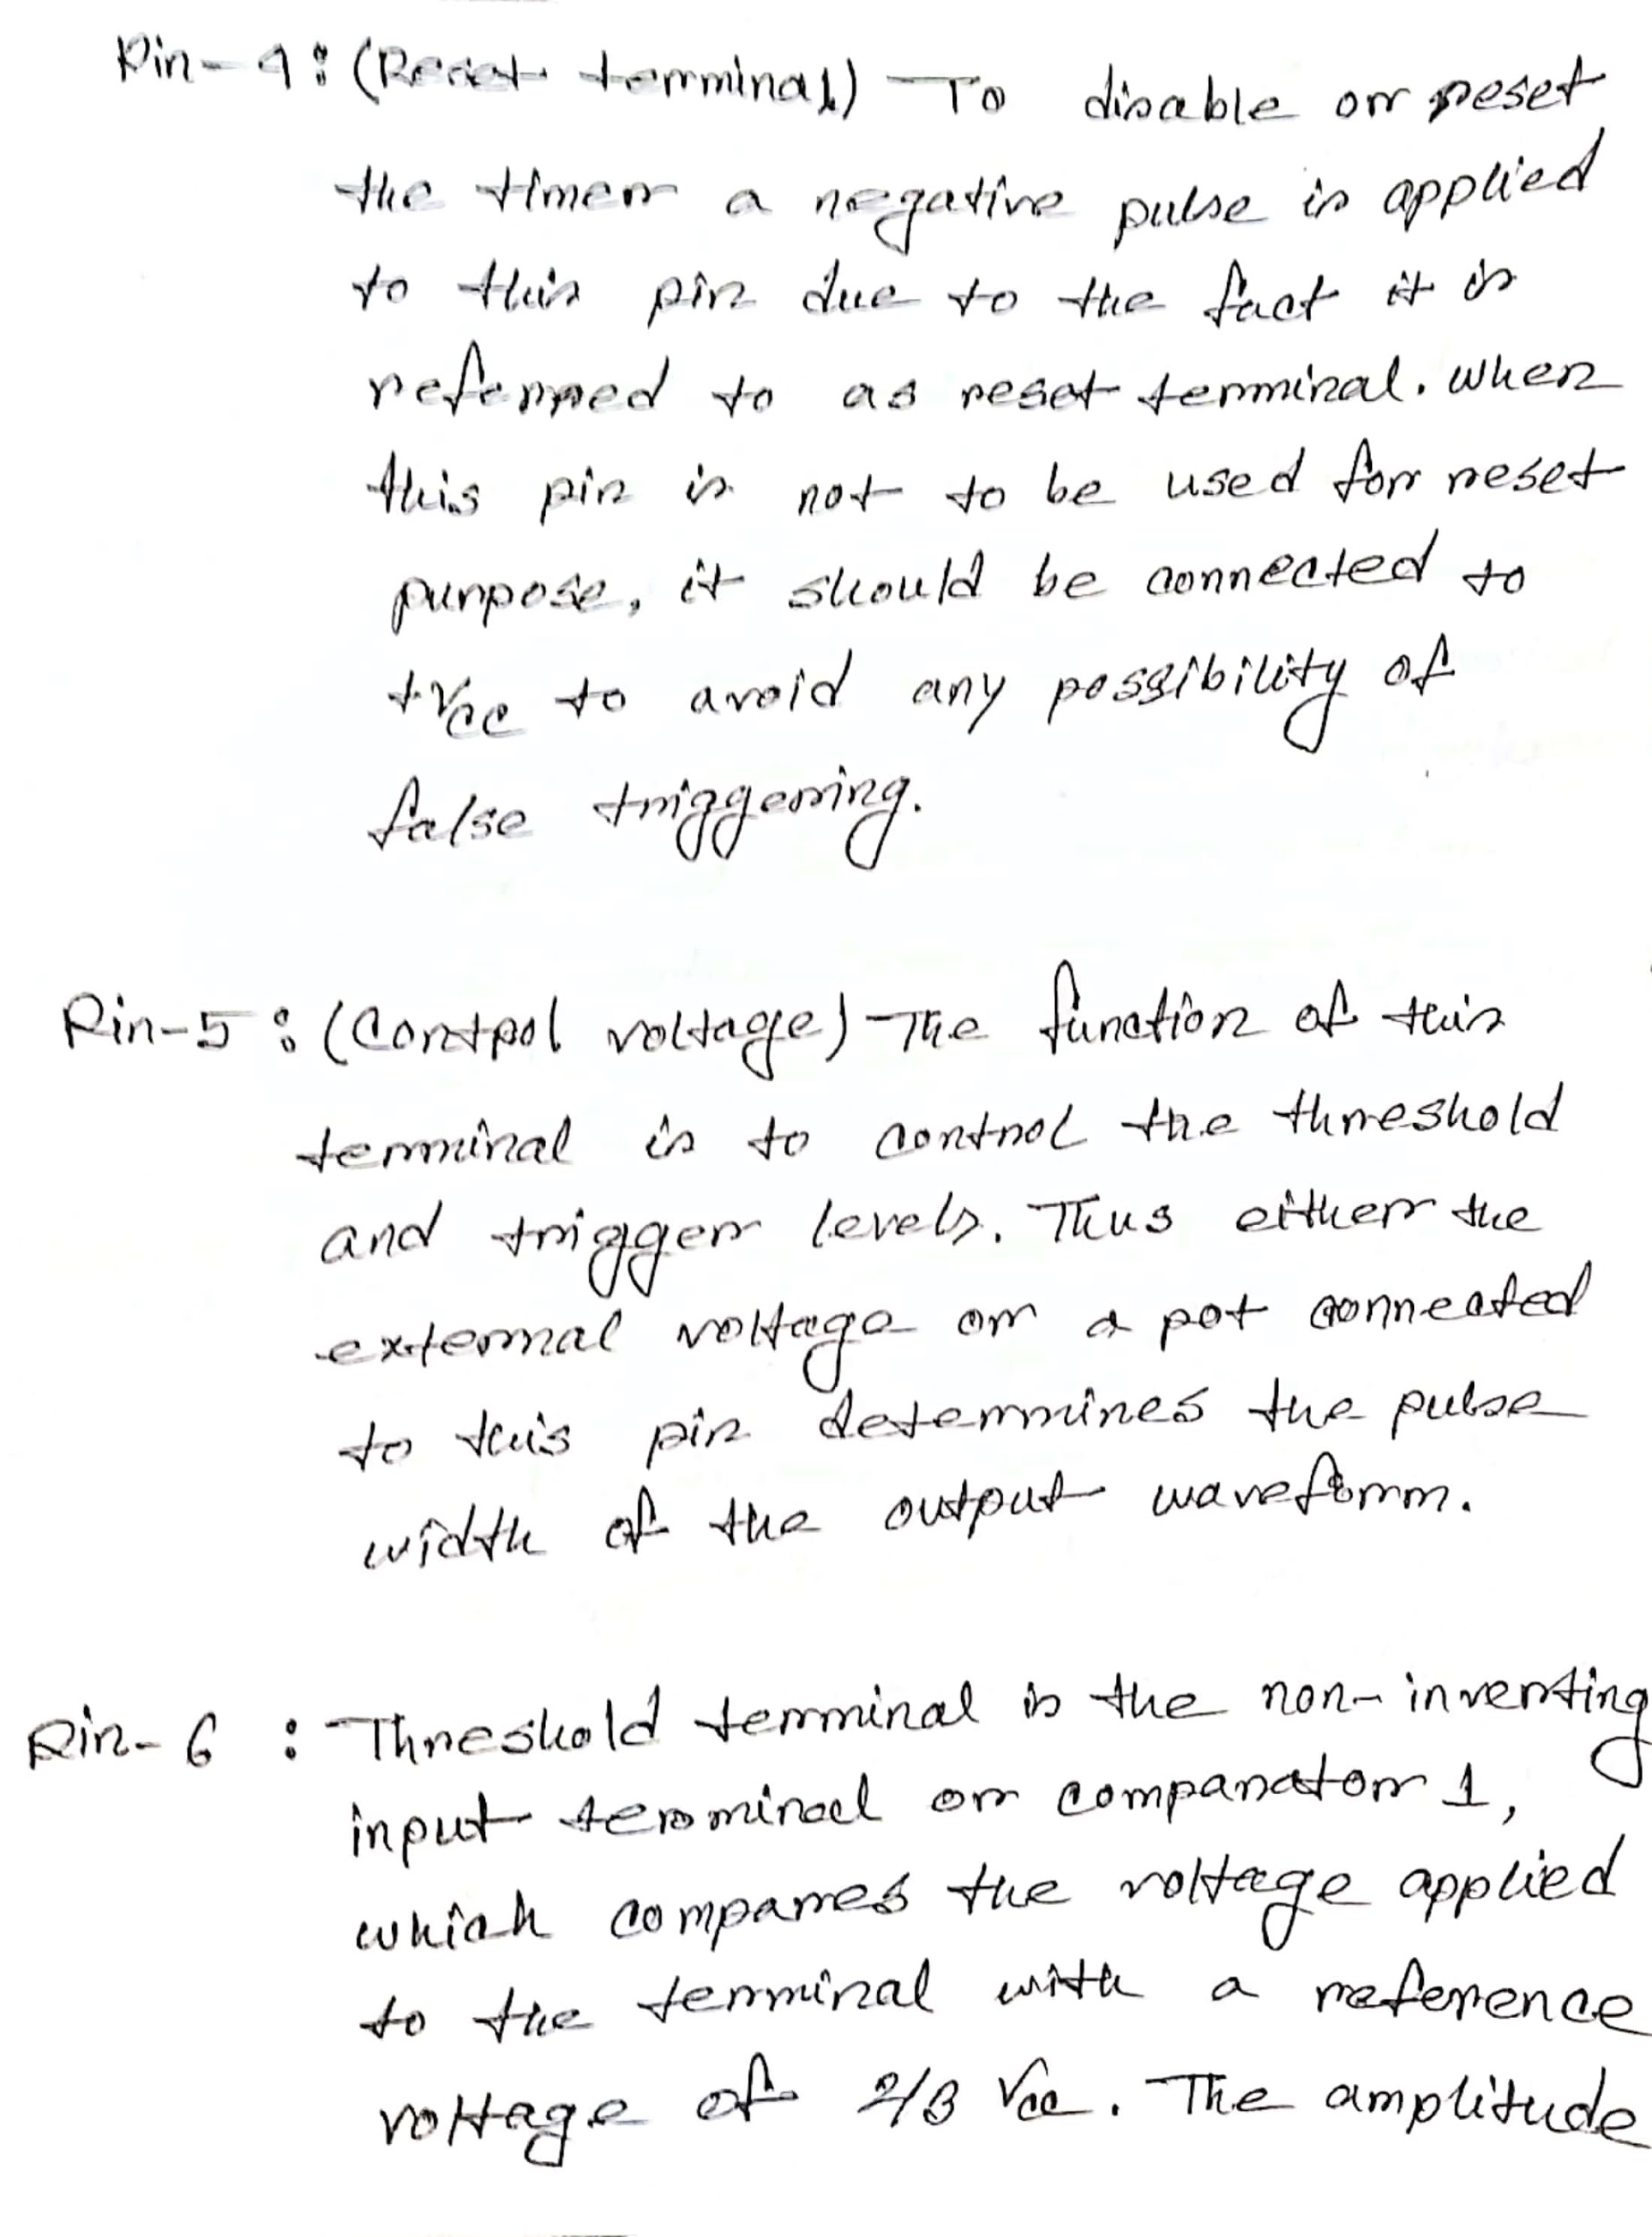  
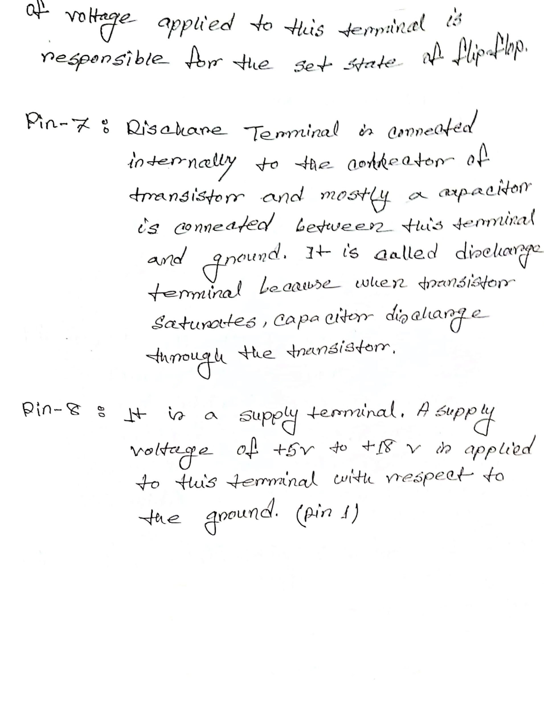  
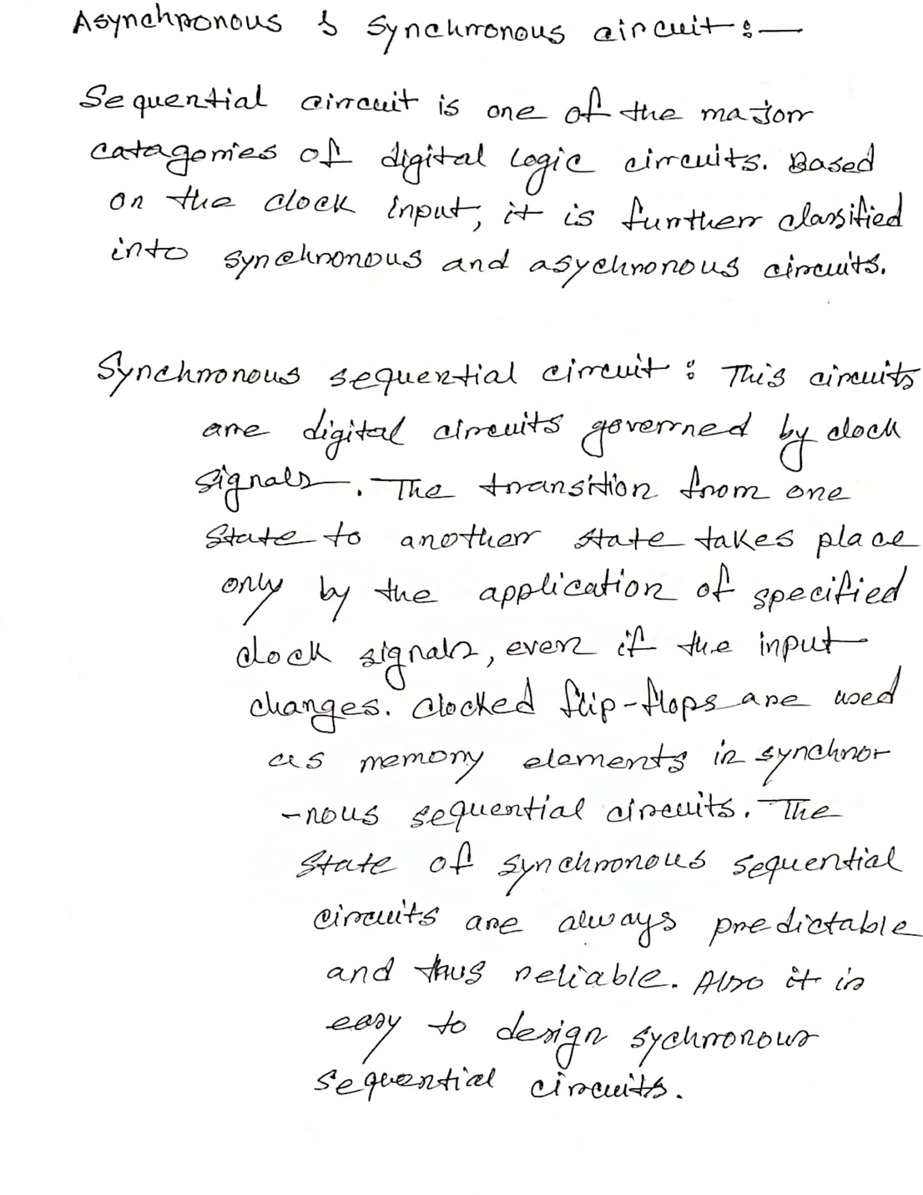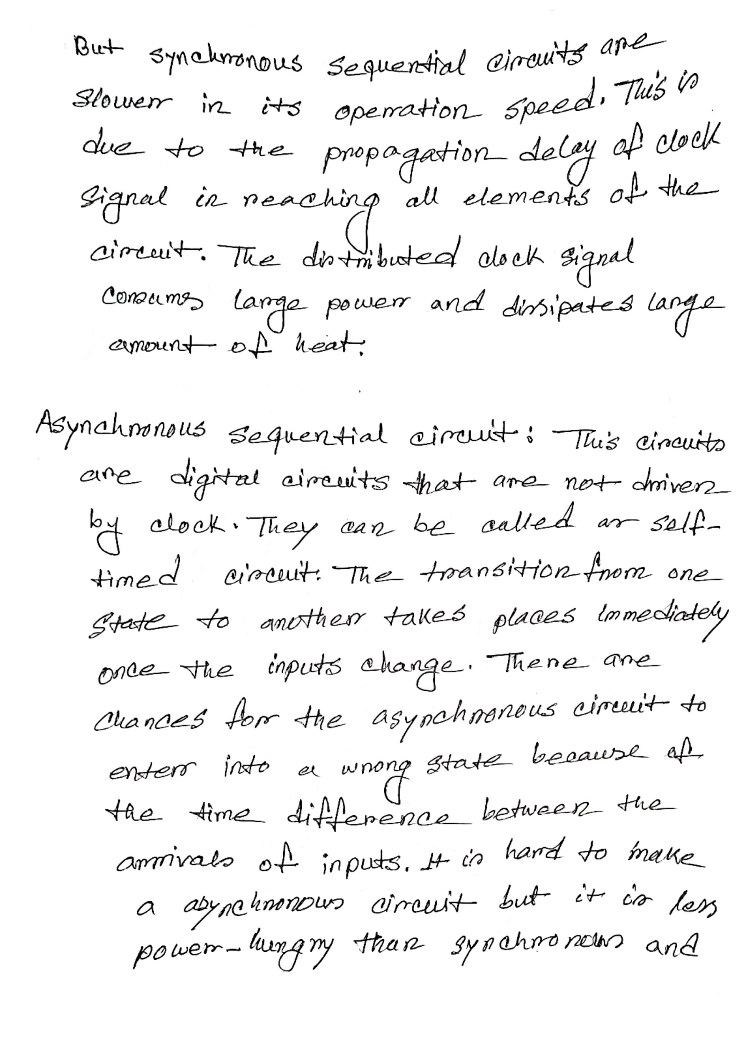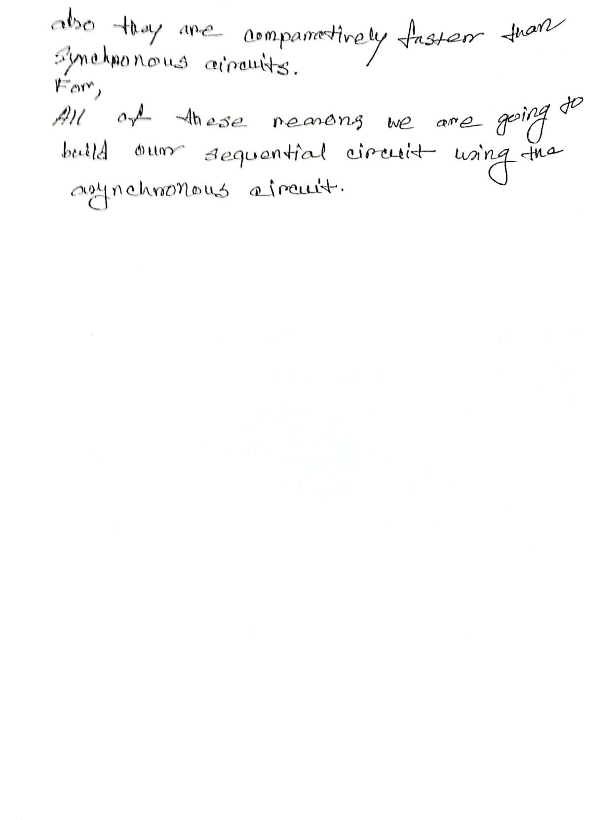  
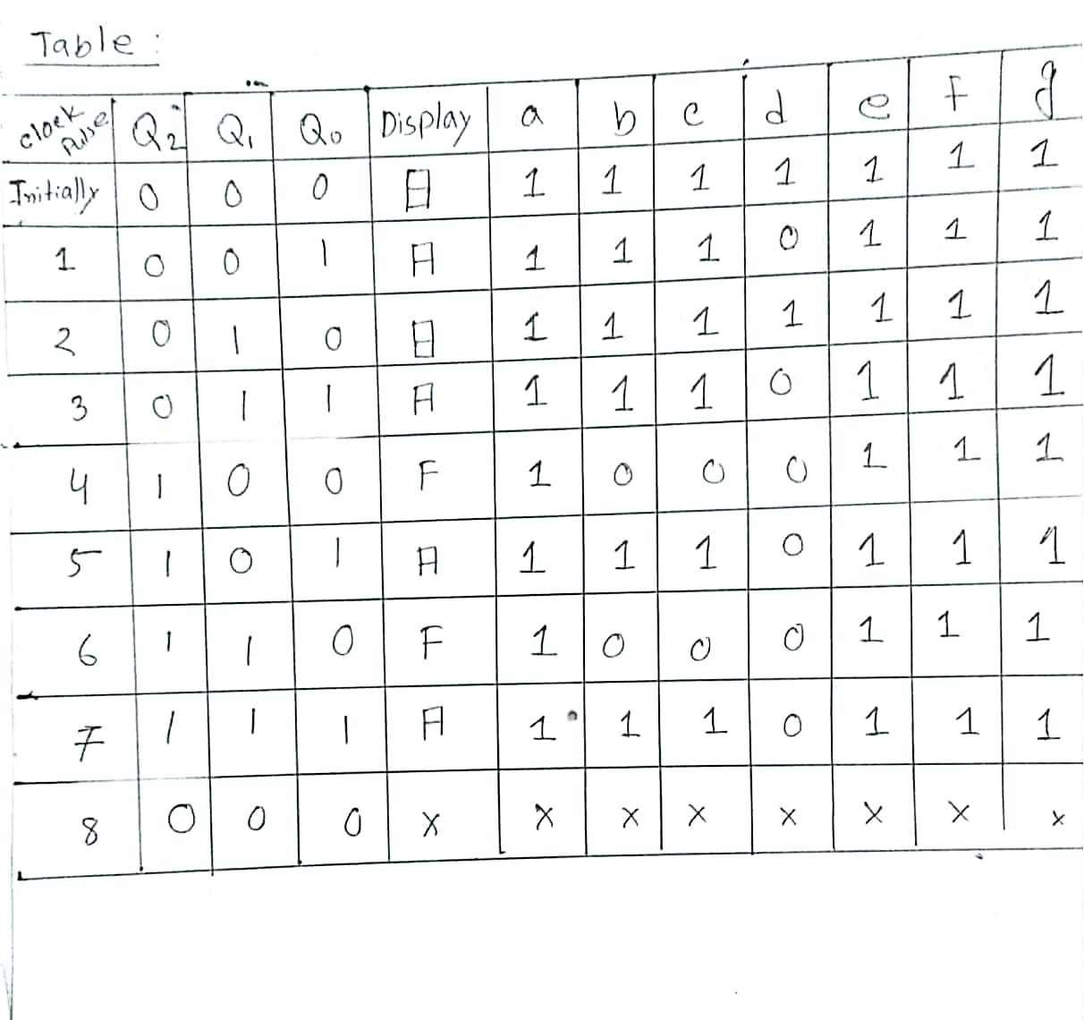  
 Figure: Table  
  
  
  
  
  
  
  
  
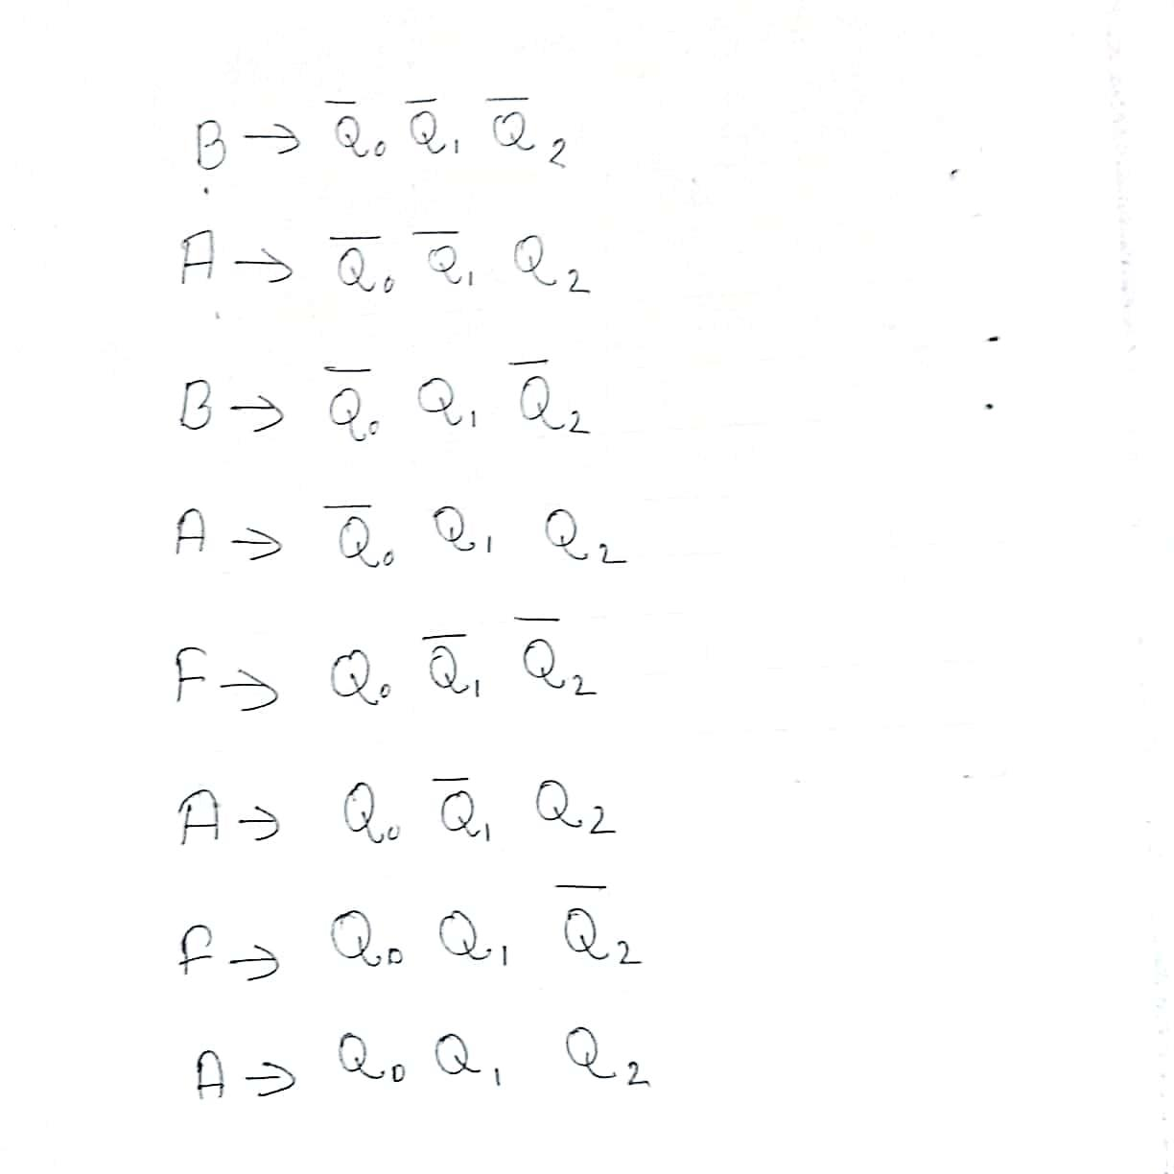  
  
  
  
  
  
  
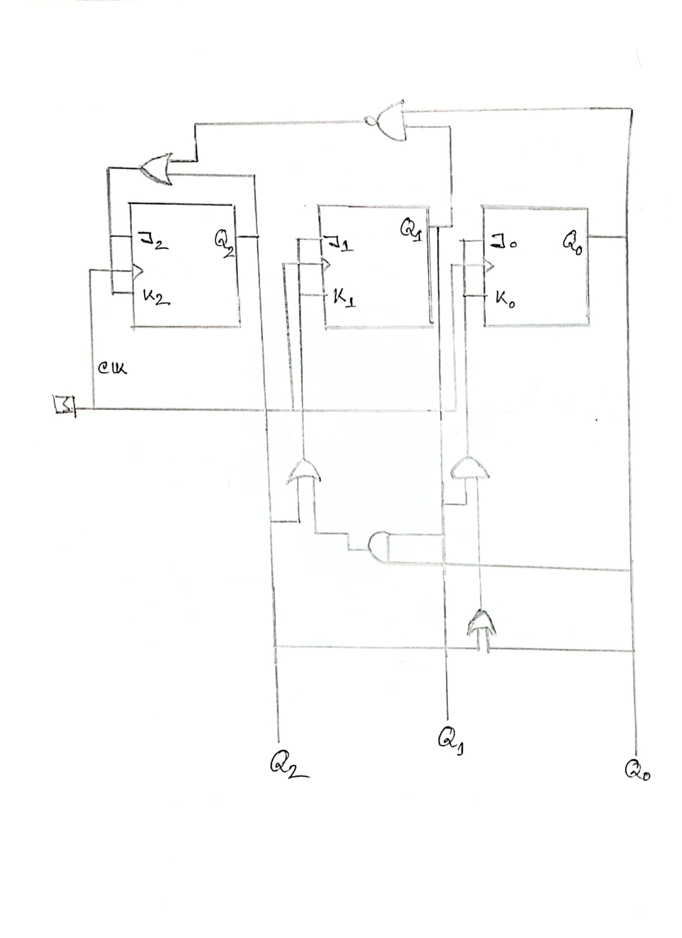  
Figure: Sequential circuit Diagram  
  
Logisim:**  
